

CIVIL DESIGN CONSIDERATIONS CASE STUDY:
CAMERA STRUCTURE EXERCISE

INSTRUCTOR VERSION
February 22, 2017

Table of Contents
YOUR ROLE 1
Task 1: Siting 1
Task 2: Power 10
Task 3: Communication 13
Task 4: Structural Design 16
Task 5: Project Evaluation 22
Final wrap-up 23
APPENDIX - BACKGROUND INFORMATION 24

List of Figures
Figure 1 - Interstate Intersection 2
Figure 2 - South on I-29 3
Figure 3 - East on 12th Ave 3
Figure 4 - West on 12th Ave 4
Figure 5 - North on I-29 4
Figure 6 - Sign on North Side of 12th Ave. 5
Figure 7 – 1st Location: South Side near Overpass 6
Figure 8 – 2nd Location: North Side near Intersection 7
Figure 9 – 3rd Location: North Side on Existing Sign Structure 8
Figure 10 - Boring Log 18
Figure 11 - Pole Design 19
Figure 12 - Pole Mounting Design 20
Figure 13 - Pole-mounted Cabinet Detail 21

List of Tables
Table 1 - Site Characteristics Summary 8
Table 2 - Power Budget Estimates 11
Table 3 - Revised Power Budget Estimates 11
Table 4 - Communication Options 15
Table 5 - Summary of Project ITS Elements 26
Table 6 - Common ITS Component Costs 27
Table 7 - Selected ITS Project Elements 28
Table 8 – Estimated First Year Costs 29
Table 9 – Typical Organizational Responsibility 29

The following is an exercise that will allow you to explore the relationships of ITS to civil design in deploying a surveillance camera. This builds on the exercise used in the National ITS Architecture Case Study material. In the setting of a major university event trip generator – a Saturday afternoon football game, you will design the mounting structure for a surveillance camera to be located at the intersection of the Interstate and a major arterial. Instructions about each of your tasks follow the description below. You will develop a document recording your findings and answering the questions within the tasks.

YOUR ROLE
You are a new traffic engineer at the City’s Department of Transportation (City DOT) for a medium-sized Midwestern city. Your job responsibilities to this point have included traffic studies, data collection, traffic signal timing, and numerous other tasks. Your supervisor has been a City DOT engineer for 20 years and did all the same type of work you are doing now. However, with recent technological advancements in the traffic and transportation field, some new approaches to how the City manages its transportation system have been introduced. While your supervisor understands the benefits of this approach, there is apprehension about how it all works. Your assignment is to develop the plans needed for installation of a surveillance camera to be controlled by an existing TMC near the center of the City. Background information is provided in the appendix. The background information provides information about the components of the ITS project that includes the surveillance camera installation at the Interstate.

Task 1: Siting
For surveillance applications, line of sight is a critical consideration. The most reliable line of site study takes place on site at the planned location and height of the desired camera. In most cases, such a study involves collecting images using a camera or video recorder with capabilities similar to the planned surveillance camera while elevated in a bucket truck. Depending on the roadway and shoulder locations as well as the jurisdictional regulations, such a survey may entail traffic control and a maintenance of traffic plan.
For our sample deployment location, we are attempting to provide video surveillance of both the arterial and the interstate near the interchange of I-29 at 12th Avenue, North. The edge of campus is about 1.5 miles east, the football destination is about a mile North from there, and the center of town is about 3 miles Southeast. The interchange is shown in Figure 1. As a side note, students interested in freeway design will recognize this interchange as a partial cloverleaf. The partial cloverleaf removes the undesirable weaving area of the full cloverleaf at the cost of a traffic signal on the minor roadway to accommodate one of the turning movements of vehicles leaving the major roadway.

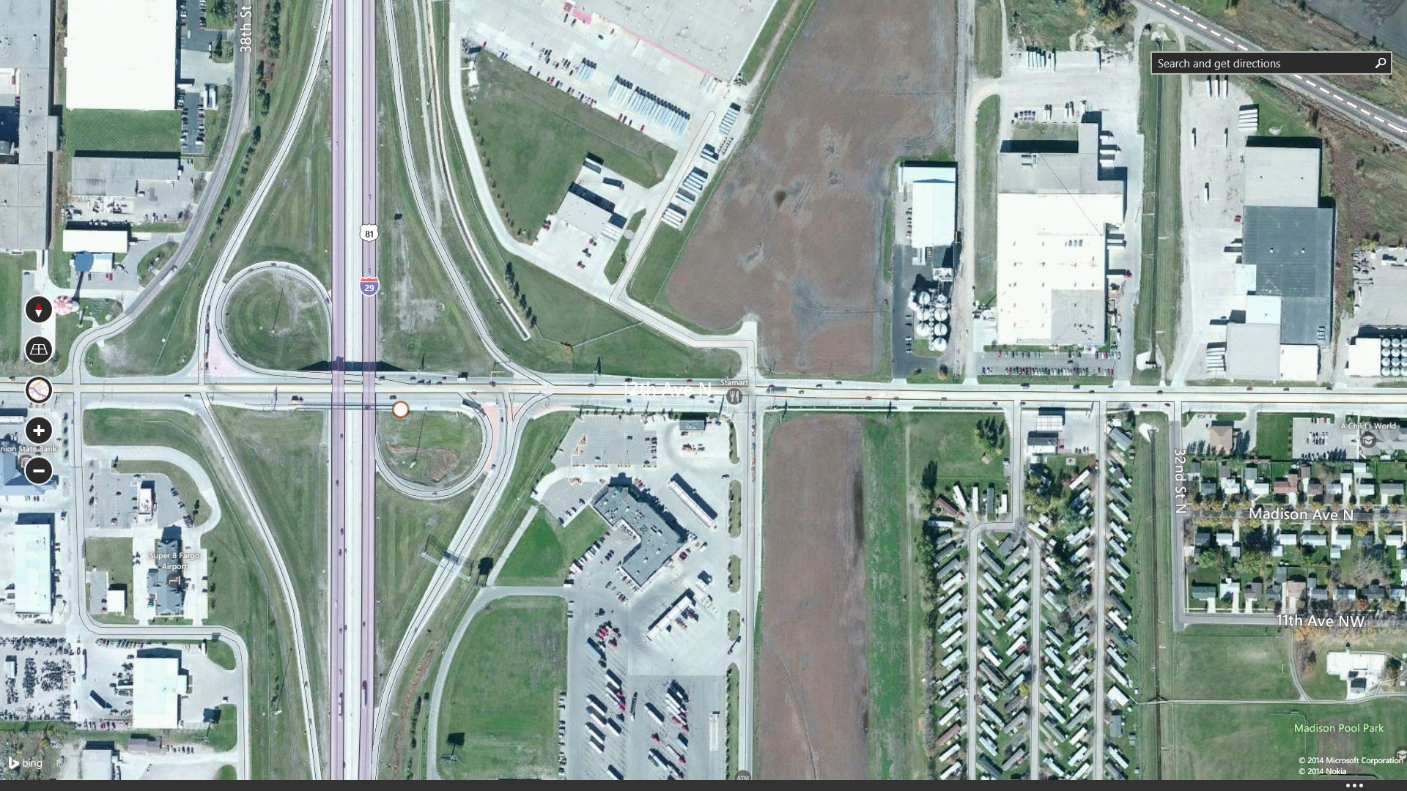
Figure 1 - Interstate Intersection

Figure 2 through Figure 5 show the site lines looking along the crossing roadways. These images indicate that the terrain is flat and the roads are straight with few obstructions. The major obstruction is a road sign on the North side of 12th Avenue between the Westbound to Northbound ramp and the Eastbound to Northbound cloverleaf ramp, shown in Figure 6. The choice of mounting height versus location is a combination of camera utility and installation cost. Several alternative locations should be developed prior to performing the bucket truck survey. In addition to the ability of the device to perform the intended function, characteristics to consider include access for installation, traffic impact for installation, proximity to utilities, proximity to conduit plant, ability to erect a structure, need to protect a new structure, ability to use an existing structure, costs to provide adequate mounting, environmental impacts, conflicts with existing roadway furniture, and any remedial work required if existing infrastructure is used.

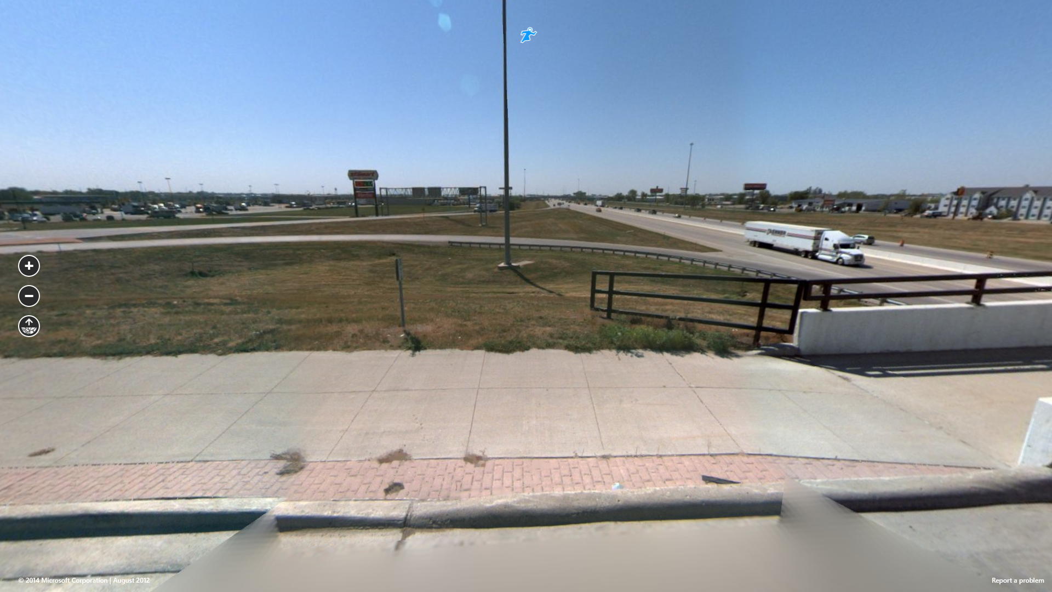
Figure 2 - South on I-29

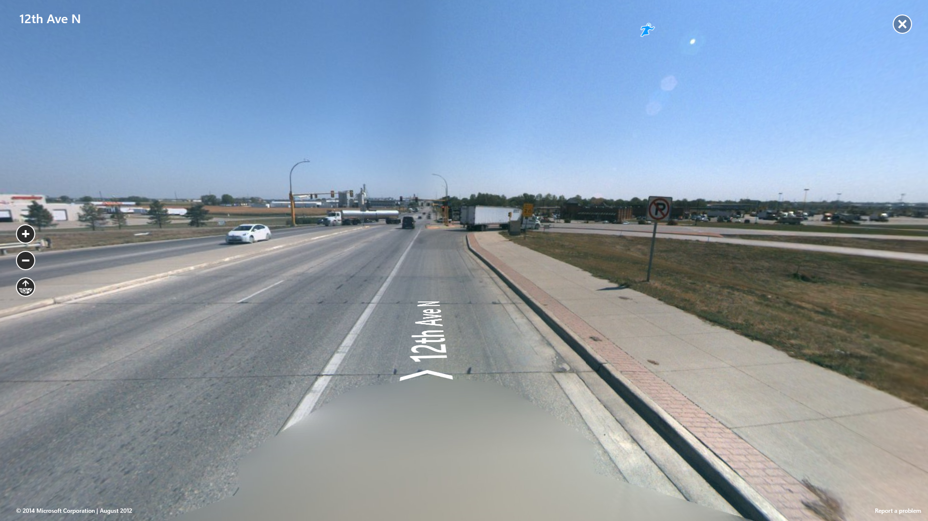
Figure 3 - East on 12th Ave

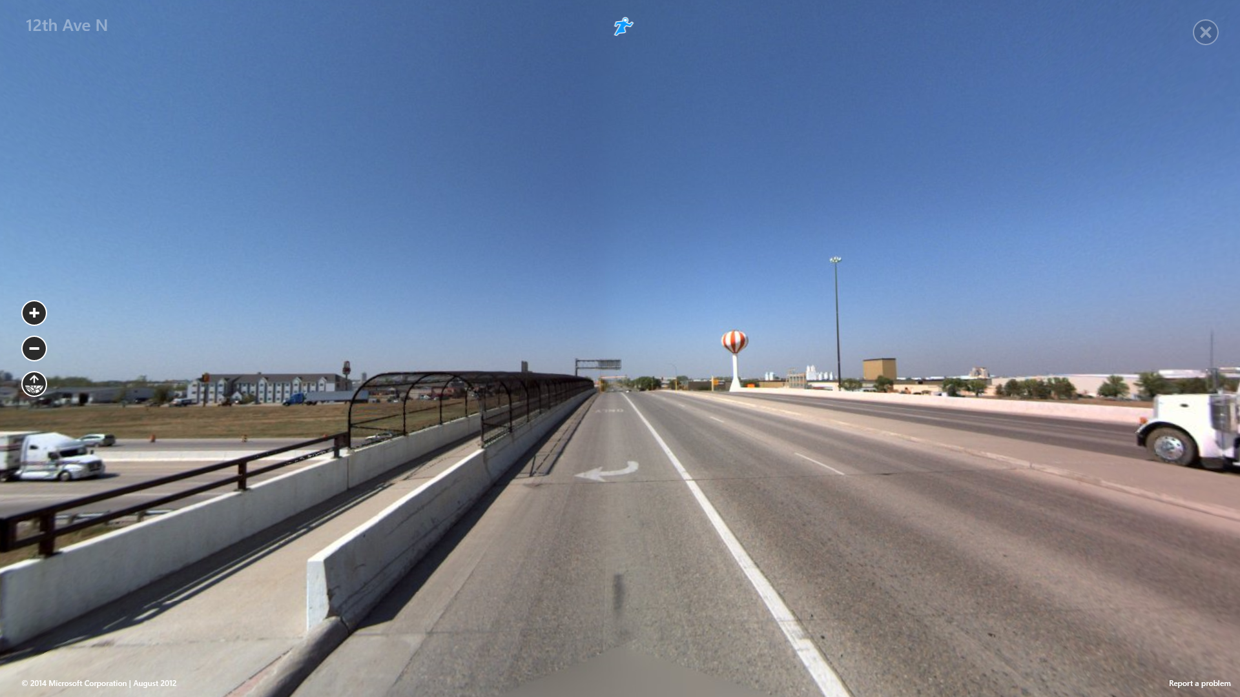
Figure 4 - West on 12th Ave
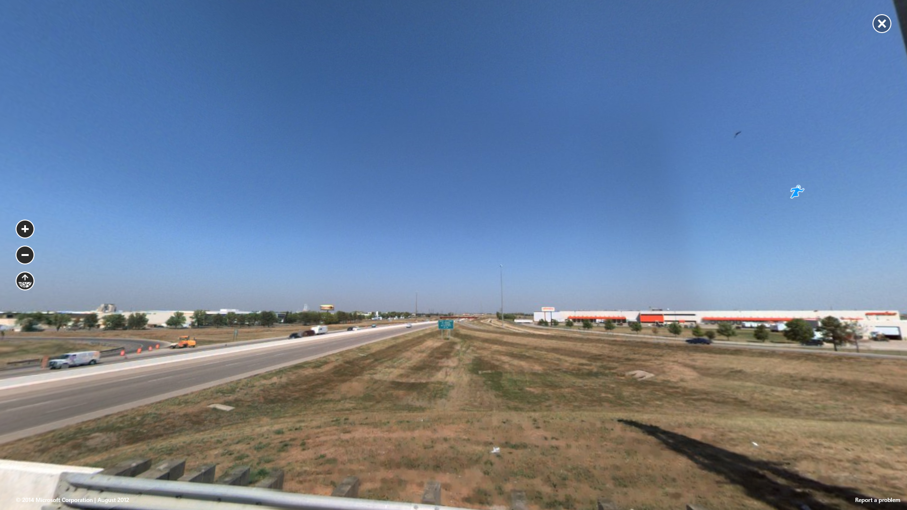
Figure 5 - North on I-29
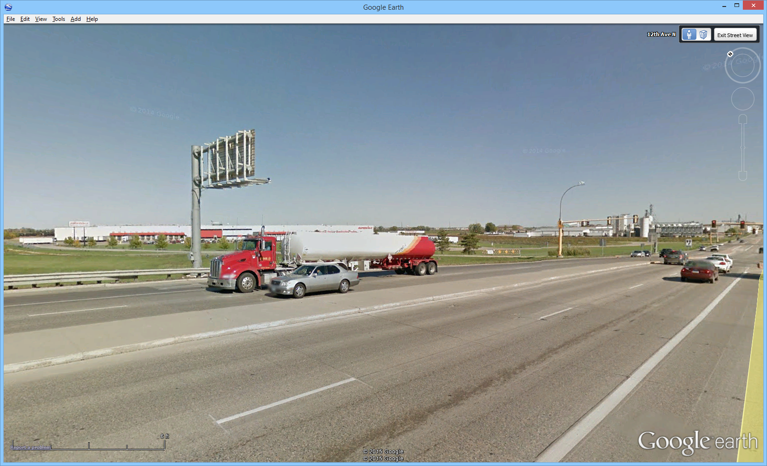
Figure 6 - Sign on North Side of 12th Ave.
For this exercise, we will consider three potential locations. It should be emphasized that agencies may value characteristics of the locations differently and the “best” choice may be different depending on agency and project priorities.
The candidate locations share a number of characteristics that are applicable to a larger area. Existing communication infrastructure is not in the immediate vicinity of the interchange, so each candidate location is equally weak in access to communication infrastructure. No hydrological or endangered species constraints are present in the interchange right of way. Soil conditions are favorable for camera pole foundations.
The first location for consideration is east of the freeway on the South side of the arterial, as shown by the white circle at the interchange in Figure 7. This location gives superior line of sight for the camera if the static sign can be accommodated. A new pole would be required, with access to power provided from the adjacent static sign. The candidate sight for the new pole is partially protected by the existing pedestrian walkway and handrail, but additional study would be required to determine if additional barriers or guardrail is required. Access to the site has no major obstacles and construction has no impediments. At this location the static sign is a factor in mounting height. The camera pole should be designed to elevate the camera high enough to provide site lines where the sign face only obstructs view of a portion of the area between the ramp and the roadway. Positioning the camera on the South side of the arterial to the West of this sign on a shorter pole limits the obstruction to impacting a small portion of the Westbound to Northbound ramp. Overall, this is a very good candidate location.
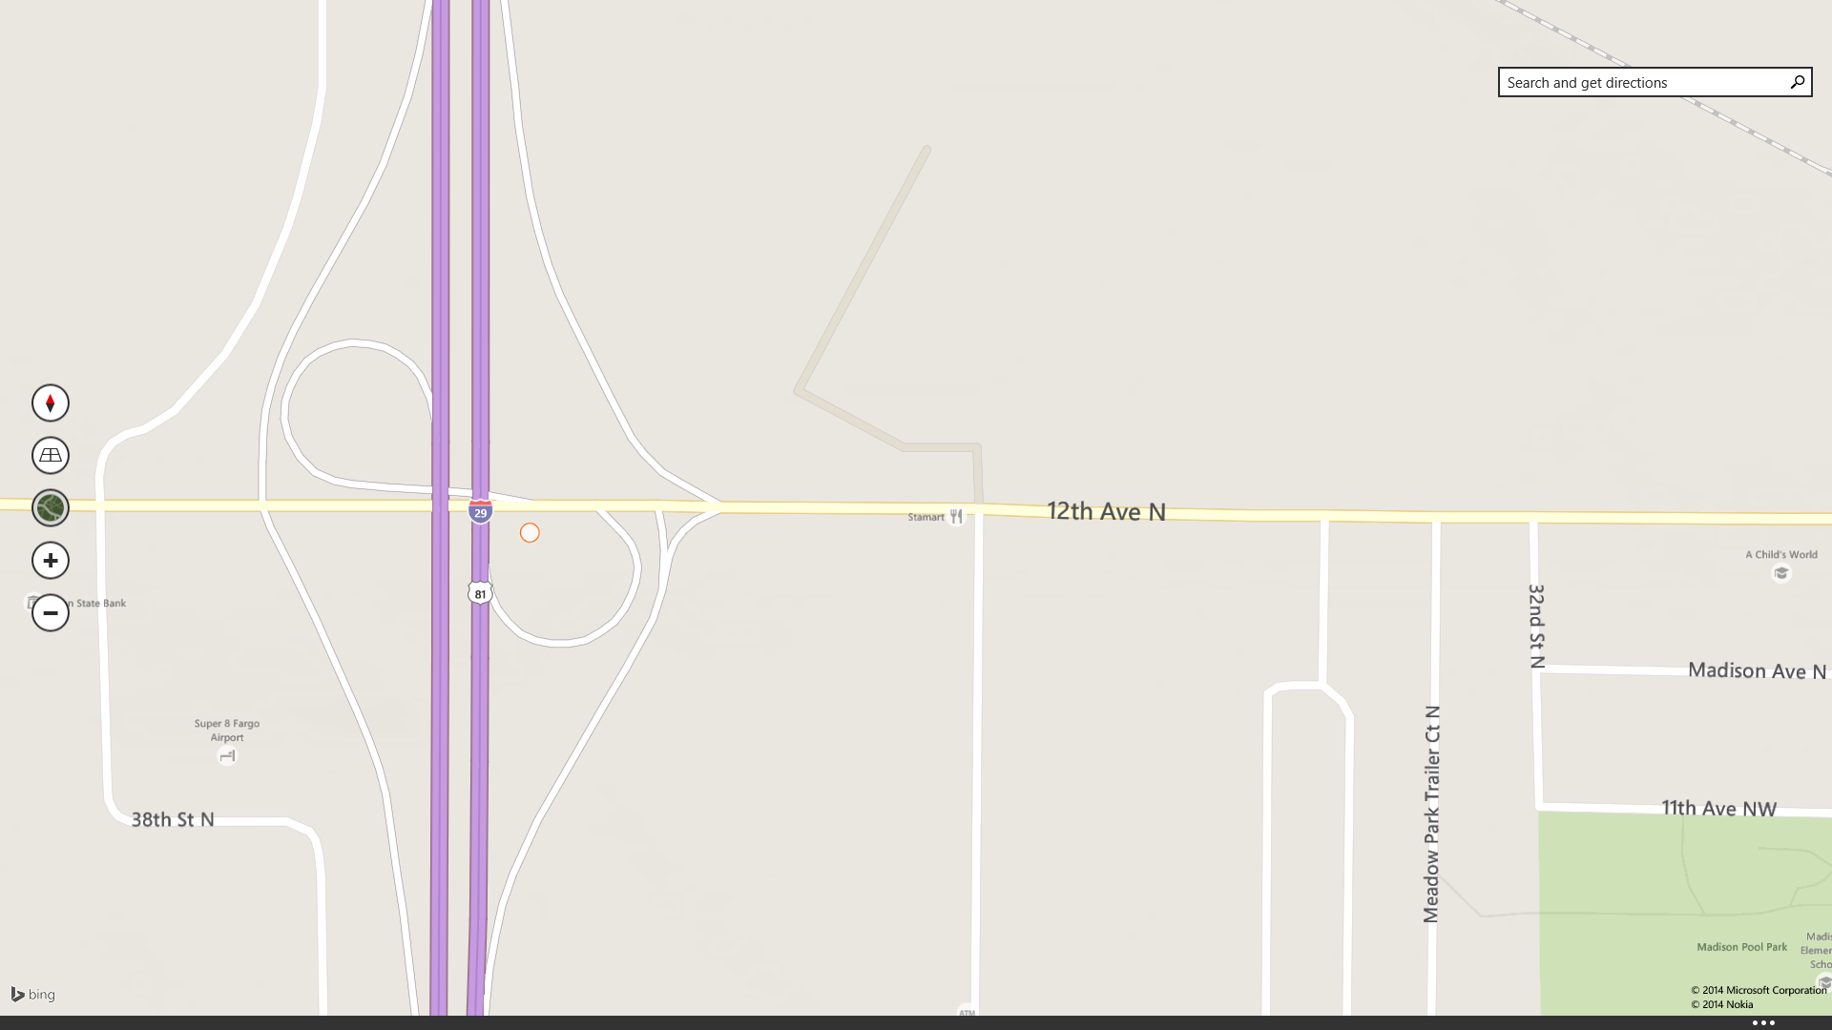
Figure 7 – 1st Location: South Side near Overpass

The second location for consideration is near the intersection of the freeway off ramp and the arterial on the North side of the arterial, as shown by the white circle at the interchange in Figure 8. This location gives good line of sight for the camera if the static sign can be accommodated. A new pole would be required, with access to power provided from the traffic signal cabinet on the South side of the arterial. The candidate sight for the new pole is not protected from traffic, so guardrail is expected to be required similar to the existing static sign. Access to the site has no major obstacles and construction has no impediments. At this location the static sign is a factor in mounting height. The camera pole should be designed to elevate the camera high enough to provide site lines where the sign face obstructs view of a portion westbound lanes of the arterial West of the overpass. Positioning the camera on the South side of the arterial to the West of this sign on a shorter pole limits the obstruction to impacting a small portion of the Westbound to Northbound ramp. Overall, this is a good candidate location.

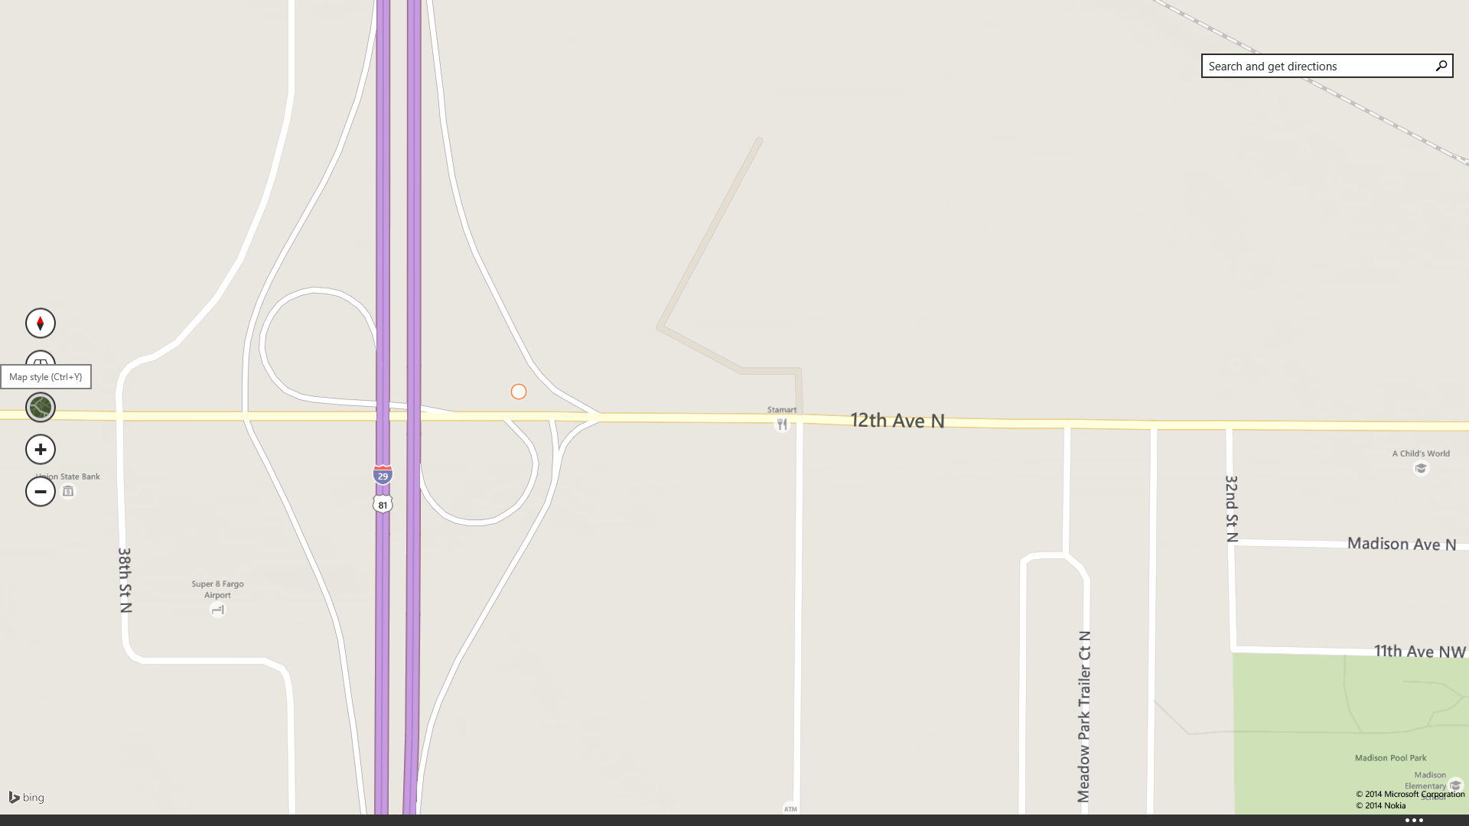
Figure 8 – 2nd Location: North Side near Intersection
The third location for consideration is atop the existing pole of the cantilevered static sign on the North side of the arterial shown in Figure 6. The location is shown by the white circle at the interchange in Figure 9. This location gives superior line of sight for the camera. A new pole extension or camera pedestal would be required for attachment to the pole, with access to power provided from the electrical service feeding power to the lights of the static sign. Access to the site has no major obstacles and no significant construction would be required. Overall, this is a very good candidate location.
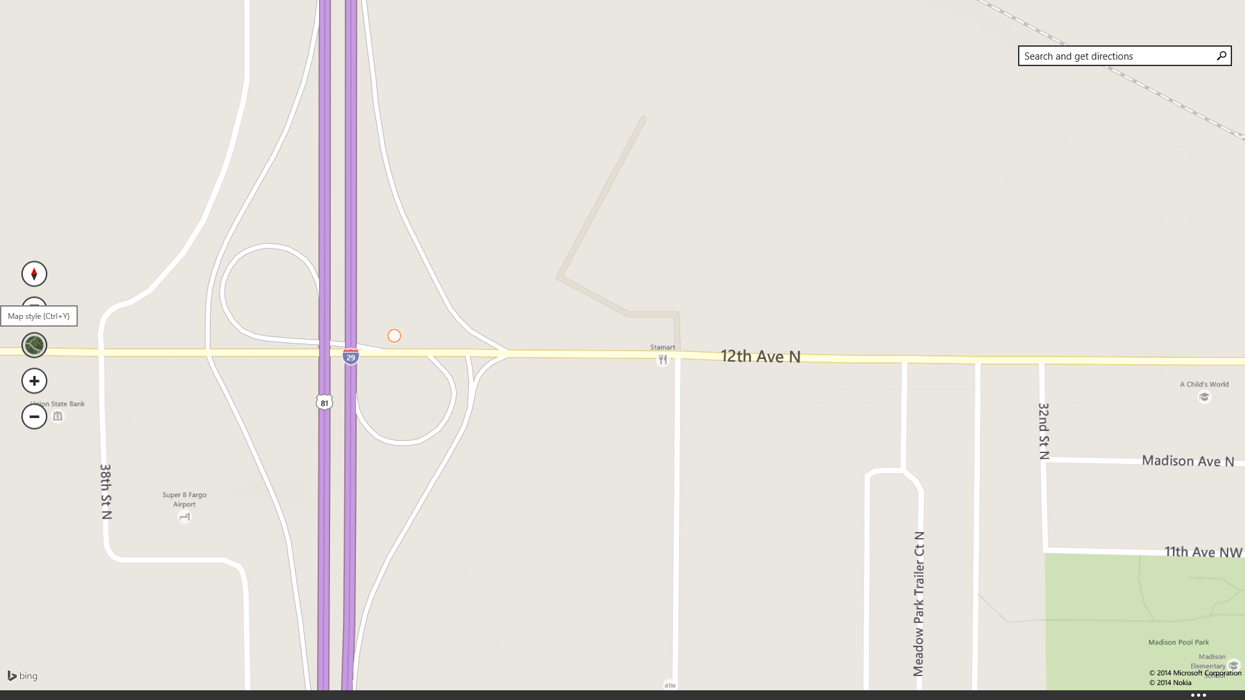
Figure 9 – 3rd Location: North Side on Existing Sign Structure

Table 1 - Site Characteristics Summary
Site # | 1 | 2 | 3
Location | S of 12th Ave | N of 12th Ave  Near NB Off Ramp | N of 12th Ave  On sign post
Line of sight | 🔴 | 🌓 | 🔴
Access for installation | 🔴 | 🔴 | 🔴
Traffic impact for installation | 🌓 | 🌓 | 🔴
Proximity to power | 🌓 | 🌕 | 🔴
Proximity to communication | 🔴 | 🔴 | 🔴
Proximity to conduit plant | 🌕 | 🌕 | 🔴
Ability to erect a structure | 🔴 | 🔴 | n/a
Need to protect a new structure | 🌓 | 🌕 | 🔴
Ability to use an existing structure | 🔴 | 🔴 | 🔴
Costs to provide adequate mounting | 🌕 | 🌕 | 🔴
Environmental impact | 🔴 | 🔴 | 🔴
Conflicts with existing roadway furniture | 🔴 | 🔴 | 🌕
Remedial work for existing infrastructure | 🔴 | 🔴 | 🔴

Ranking: | Best Worst
 | 🔴 🌓 🌕 🌓 🔴

After initial analysis of siting options, the team identified use of the existing sign structure (3rd location) as the preferred option. However, consultation with the State DOT, who owns the sign, indicated that the State did not have a precedent for placing equipment from a different jurisdiction on their structures. Furthermore, the modification of the cantilever structure including the addition of a pole-mount cabinet and placement of a camera of up to 15 pounds and 300 square inches in cross section will require consultation with a structural engineer. They estimated the coordination for approval of this option would require roughly 18 months. The option was discarded in favor of placing the camera on the South side of the arterial just East of the overpass (1st location).
Finally, answer the following questions:
- How would the analysis of alternatives change if the area had an endangered species of mole?
The options that include earthwork would require significantly more detailed planning and may be rejected depending on the findings of the detailed planning. Plans would also require concurrence from additional agencies, at least including the State Department of Environmental Protection. Expected impacts include delays in planning approval, increased costs for design, and increased cost for construction. An advocacy group could also observe carefully, or even obstruct via demonstrations. Coordination with the State for use of the existing sign pole could become the most advantageous option to pursue.
- In this scenario, are locations for siting the camera other than the three considered attractive?
The issue being addressed in this project is event-related demand that occurs 5 – 10 times per year. The event site is to the East along the arterial, with the largest volume of data arriving from the South along the interstate. The demand is shown in general terms on slide 13 of the presentation as the red highlighted arterial labeled as the Primary Congestion. The ability to observe traffic is most valuable along these roadways. Placing the camera to the West of the interstate is less desirable, but locations with the ability to see both the arterial and freeway are acceptable. Placing the camera where only one of the roadways is visible would seriously compromise the benefit of the project.
- What locations should be considered if the State DOT revokes their agreement to allow the surveillance deployment to take place in the interchange right of way?
Without access to the interchange, the ability to gain video images of freeway traffic is severely reduced. The impact of being off of the intersection right of way is increased due to the width of the interchange. Just east of the traffic signal for the Northbound off ramp would be able to see the off ramp clearly, even if the freeway was partially obstructed. Without access to the interchange right of way, my recommendation would be to reallocate the year one budget for this site to TMC design to progress that portion of the project. Surveillance of the freeway would be pursued via sharing of video images once the State implements cameras.

Task 2: Power
Power is a requirement for all ITS devices. The vast majority of sites use a dedicated utility drop, including a riser, meter, and disconnect, with the power being provided by the regional electrical utility. Sites placed close to existing powered locations (most frequently traffic signals, lit static signs, and existing ITS devices) can use the existing electrical service providing that the existing service has sufficient additional capacity. Organizational issues can arise if the existing service is billed to a different jurisdiction, such as a camera operated by a state for interstate surveillance drawing power from a city traffic signal cabinet.
Power for locations isolated from existing electrical utility lines require consideration of options. Costs for infrastructure required to reach from existing power lines to an isolated site aerial power service will typically be the responsibility of the project. If aerial lines are allowed, costs will be modest. Underground lines can be an order of magnitude more expensive. Off-grid power sources are most typically solar panels, with wind turbines used occasionally. In addition to generation of adequate power, the off-grid sites must also store sufficient reserve power to withstand the maximum expected period with insufficient insolation (for solar) or wind to recharge the batteries.
Finalization of the electrical design will require the certification of a Professional Engineer. As part of the design, the engineer will demand information on the power load of the devices to be powered through the cabinet, including devices located inside the cabinet and the devices with power coming from the cabinet, such as the camera in our scenario. In general, the engineer will request this information prior to approval of all devices, including the communication devices. Providing both an expected power draw and a maximum possible power draw will allow the power design to be completed. If the power load requires modification to planned source, a redesign of the source will be required or a different source can be used to power the site.
For this exercise with the selection of the site on the South side of the arterial, power has been offered from the existing State DOT power source being used for lighting of the static sign mounted on the arterial overpass. For planning purposes, we will assume that the cabinet will need to power the camera along with an Ethernet switch. Additionally, each cabinet is required to include a utility light, ventilation fans, a cabinet monitor, and a convenience outlet with the capacity to carry a 200 Watt device. With these devices, an estimate of load and annual costs is shown in Table 2.
Table 2 - Power Budget Estimates
ITS DEVICE TYPE | MAX WATTAGE | EXPECTED WATTAGE | DUTY CYCLE | KWH/  YEAR | POWER COST
Camera | 100 | 75 | 100% | 657 | $78.89
Ethernet Switch | 50 | 25 | 100% | 219 | $26.30
Light | 10 | 5 | 1% | 0 | $0.05
Ventilation | 10 | 7 | 10% | 6 | $0.74
Cabinet Monitor | 10 | 5 | 100% | 44 | $5.26
Convenience outlet | 200 | 200 | 1% | 18 | $2.10
Total | 380 | 317 |  | 945 | $113.34

As part of a typical civil design for ITS elements, both project reviews and ongoing design in other disciplines can cause revision to a design. As part of our exercise, communication design introduces an additional device and complications. The additional communication device required is a 4G router. The complication is that the standard 4G router has an operating range of -20°C - 60°C, which is not adequate for a traffic cabinet in winter in much of the US, including near our site. The solution previously used by state projects is to install a strip heater in the cabinet. The revised power budget is shown in Table 3. While the revisions are probably not significant, the additional power budget requires a second review for adequacy of the existing electrical service by State DOT representatives. If this power budget cannot be accommodated by the existing service, previous plans for power source and even camera siting will be reviewed along with associated costs. Impacts from such a review may indicate that the plans are adequate with budgetary revisions to accommodate the increase in service or may lead to a different site decision is superior.
Table 3 - Revised Power Budget Estimates
ITS DEVICE TYPE | MAX WATTAGE | EXPECTED WATTAGE | DUTY CYCLE | KWH/  YEAR | POWER COST
Camera | 100 | 75 | 100% | 657 | $78.89
Ethernet Switch | 50 | 25 | 100% | 219 | $26.30
4G Router | 10 | 5 | 100% | 44 | $5.26
Strip Heater | 150 | 150 | 5% | 66 | $7.89
Light | 10 | 5 | 1% | 0 | $0.05
Ventilation | 10 | 7 | 10% | 6 | $0.74
Cabinet Monitor | 10 | 5 | 100% | 44 | $5.26
Convenience outlet | 200 | 200 | 1% | 18 | $2.10
Total | 540 | 472 |  | 1054 | $126.49

Continued operation of ITS devices through a power outage is a frequent requirement. Most commonly, short outages are protected against by using a Battery Backup System (BBS) or an Uninterruptable Power Supply (UPS). These devices consist of electronics that generate AC current similar to standard power available from standard outlets along with rechargeable batteries sized to meet project requirements. For North America, the current is usually 110 V at 60 Hz. For devices in other parts of the world, 220 VAC at 50 Hz is common. The BBS will sit between the grid power and the protected devices. While grid power is available, the BBS will charge the battery pack while performing surge suppression and other power monitoring services. Some BBSs will always provide power to the protected devices, using grid power while it is available and switching to battery power when the grid power is out or inadequate. Other BBSs operate in a standby mode when grid power is available, switching to actively provide power to the protected equipment when grid power is out or inadequate.
A typical requirement for a camera site is operation of the ITS device and related communication equipment for ½ hour of power outage. At 110 Watts for carried equipment, a very small BBS supplying 55 Wh would be required. A small BBS such as this would typically draw well under the 540 W in the revised power budget when recharging, so no revision to the power service would be required. An alternate policy would be that the camera should be able to operate for the entirety of a game day even if power was out. This policy would require operation for up to 16 hours, requiring a BBS supplying 1¾ kWh. This larger BBS could require 10 Amps while recharging, which would become the dominant factor in selecting the power service. The maximum current draw from the grid would be a function of the BBS selected, which will in turn be driven by the uptime requirements in the presence of a power outage. Items not powered through the BBS would also need to be added to the service sizing calculation.
Finally, consider the following questions:
- Which components of the site should be powered by the Battery Backup System (BBS), if one was required?
For emergency operations, only the equipment directly providing transportation service should be included in the backup calculations. In this scenario, the camera, Ethernet switch, 4G router, and cabinet monitor will be carried on the BBS, while the ventilation, lighting, strip heater, and convenience outlet can be left unpowered if the grid power is unavailable.
- How would components of the site need to be revised if power came from a solar source?
Solar panels would need to be mounted and sufficient storage capacity to meet the power requirements would be needed. The sizing of the solar power source would depend on the average power draw and storage sizing would depend on the harshest power conditions required for supporting operations. If off-grid power is required and difficult to provide in sufficient quantity, revision to maximum allowable power for devices may be required, either by selection of more efficient equipment or operational policies to reduce the duty cycle. Consultation with an Electrical Engineer with experience in renewable energy and power storage is recommended.
With current technology, power storage is performed using batteries, but the battery technology (Lithium-ion, lead-acid AGM, sodium-sulfur, etc.) is undergoing significant active research, putting even general guidance on size and cost into flux. Typical requirements for powering equipment mandate that the system operate for a period of 7 days in the absence of any power input. With a power budget of ~2.5 kWh/day, a 7-day outage requirement would require energy storage of 17.5 kWh. The size of solar panels required to provide an average of 2.5 kWh/day is 40 – 80 square feet and is strongly dependent on environmental factors (geography, average cloud cover, vegetation, daylight hours) of a particular installation.

Task 3: Communication
Remote communication requirements range from no communication required to several megabits per second with outages of less than a few seconds per day. An example of a device with no required remote communication is a traffic detector that senses vehicles for a traffic responsive signal controller that runs independently from surrounding signals. The highest bandwidth single ITS device is a camera, which can require up to 4 mbps of bandwidth. While ordinary surveillance can have reliability requirements of 99% (about 15 minutes of outage per day allowed), surveillance used for incident detection or obstacle detection can require reliability of 99.9% (about 1.5 minutes of outage per day allowed) or 99.99% (less than 10 seconds of outage per day allowed).
In our scenario, the camera will be producing a video stream at up to 4 mbps at all times. Since this is not a safety-critical application, a reliability of 99% will be adequate. The decisions related to communication involve returning the stream from the camera to a location where its presentation is valuable, in this case the City TMC. Since this is the first surveillance camera deployed in the area, there is no existing video management system or video display system.
The cost of providing communication is the second most important consideration, behind meeting performance characteristics. The costs are a combination of electronics, infrastructure, and (if applicable) service fees. Electronics are most commonly Ethernet devices designed to work over either fiber optic or copper media or go over the air. The electronics typically cost several hundred to several thousand dollars for each site, including repeater sites, if needed. Infrastructure costs are fiber or copper cables along with conduit to protect the cables. Most commonly, conduit is required to be buried, with occasional use of aerial cable and conduit mounted to structures.
The best way to avoid infrastructure costs is to use existing cables. This can be accomplished most easily if unused strands of in-place cables are available. Many areas have copper multi-pair installed extensively in the vicinity of traffic signals. These cables were frequently installed to allow for coordination between traffic signal controllers using modem speeds of 1.2 – 56 kilobits per second. Early ITS deployments along freeways also used multi-pair for serial connections. While both communication technologies are largely obsolete in ITS usage, Digital Subscriber Line (DSL) technology can leverage unused copper pairs to provide Ethernet connectivity over a distance of several miles with a bandwidth of 10s of megabits per second and acceptable reliability. Newer installations most commonly use single mode fiber optic cables. Many existing installations of fiber optic cables have spare strands by design. Some older device technologies required dedicated fiber allocation, allowing device upgrades to concentrate data traffic on fewer fiber strands and making more strands available as spares.
Evaluation of security needs to consider both the character of the application being deployed as well as the anticipated future applications using assets of the current project. In our exercise, video streams of traffic have few security considerations, as these images are frequently made available freely on the Internet, while control of video cameras require additional considerations. Communication options that use infrastructure accessing cabinets including traffic control devices or publicly visible displays require more attention to security to avoid embarrassing or dangerous security breaches.
Like a vast majority of ITS applications, data traffic for our exercise will be carried using Ethernet. The most common media for Ethernet include:
- Owned fiber – This is generally the preferred method of communication as it provides high bandwidth and high reliability in a secure environment using ubiquitous, standards-based electronics. Signals can be sent significant distances without the need of repeater sites, while sites can be added by splicing into a fiber with a lot of flexibility in location and frequency. The weakness of owned fiber is the expense associated with the linear infrastructure. In our exercise, the cost for getting from the desired camera site to the existing copper infrastructure 2000’ distant would exceed $50,000, which makes this unattractive. Additionally, upgraded electronics required to carry data traffic back to the TMC would add on the order of $10,000 to the option.
- Owned copper – This is most frequently used when legacy multi-pair is in place. In this scenario, no copper is in place near the desired camera location and the costs of installation of new copper cable to reach from the new camera site to the existing copper infrastructure are similar to the costs of new fiber. There would be little advantage in use of owned copper over owned fiber.
- Unlicensed wireless – This option uses a single wireless hop to reach from the camera site to the existing copper infrastructure. The wireless hop provides low-cost, point-to-point connections, with the weakness that the communication has inherent reliability issues and security vulnerabilities. Short distances (less than a mile) with an unobstructed line of sight exhibit excellent reliability. Longer distances and paths with limited obstructions can work acceptably in some circumstances. While current security and encryption techniques can significantly improve security, some network administrators prohibit the connection of wireless devices to their networks. In our scenario, the path from the proposed camera site to the existing copper infrastructure can easily be traversed with a single wireless hop and the city IT manager has accepted the use of wireless transceivers with hardware-based security matching. The total cost of the transceiver pair is estimated at $1000 - $2000. The upgraded electronics required to carry data traffic back to the TMC would add on the order of $10,000 to the option, as with previous options. Unlicensed wireless coupled with incorporation of Ethernet over legacy copper multi-pair is an attractive alternative for this scenario.
- Wired ISP – This option leverages the infrastructure of commercial Internet providers, which are typically telephone companies and cable television providers. It is advantageous for gaining access to individual sites distant from owned infrastructure and providing high-bandwidth backhaul over a significant distance. The largest weaknesses are the ongoing service fees required by the ISPs and the inherent security issues related to use of other organization’s infrastructure with exposure to the Internet. In our scenario, the ISPs do not have infrastructure nor potential customers closer than the intersection 2000’ distant. In such a situation, the ISP will provide the service, but the installation costs would be similar to those of installing owned fiber. The lack of cost advantage and the security concerns exclude this from being the preferred options in our scenario.
- Wireless ISP – This option leverages the infrastructure of cellular telephone providers that have installed 3G and 4G equipment. It has similar advantages and disadvantages as wired ISPs, with additional cost considerations for data usage. In our scenario, the local cell company has negotiated an unlimited 4G service at $200/month with a bandwidth capability of 3 megabits per second. During the negotiation, the cell phone company acknowledged the understanding that this site would be producing video, with monthly usage of several hundred gigabytes of data. Based on the cost advantages, this is considered the preferred alternative. To limit the impact on operations budget to be carried by the city, the project has included the required 4G gateway along with 24 months of service in project implementation costs.
Relevant characteristics of the communication options are shown in Table 4.
Table 4 - Communication Options
COMMUNICATION  OPTION | COSTS |  |  | SERVICE CHARACTERISTICS
COMMUNICATION  OPTION | INSTALLATION | ELECTRONICS | RECURRING | BANDWIDTH | RELIABILITY | SECURITY
Owned Fiber | > $50,000 | $10,000 | $0 | 🔴 | 🔴 | 🔴
Owned Copper | > $50,000 | $10,000 | $0 | 🌓 | 🌓 | 🌓
Unlicensed Wireless | $0 | $12,000 | $0 | 🌕 | 🌕 | 🌓
Wired ISP | > $50,000 | $0 | $50 | 🌕 | 🌓 | 🌓
Wireless ISP | $0 | $1,000 | $200 | 🌕 | 🌕 | 🌓

Ranking: | Best Worst
 | 🔴 🌓 🌕 🌓 🔴

The recommendation resulting from the analysis of the communication options is to contract with the wireless ISP. The use of this approach introduces the need for a 4G router along with a cabinet strip heater, as described in the section discussing power needs.
During the budget review, City financial managers have found the monthly recurring service fees unacceptable, since those fees would have to be found in their operations budget. They have instead requested an option without ongoing service fees. DOT managers presented the option of installing a wireless hop to reach from the camera site to the existing copper infrastructure and from there on to the TMC, which was acceptable. This development will require a second revision to the power budget at the camera site as well as a review of the site of the existing traffic signal to be used to access the existing infrastructure.
There frequently is no corresponding professional engineer required to certify communication design.
Answer the following question about our scenario:
- How would your evaluation of the communication alternatives and siting alternatives change if the city installed fiber optic cable under the freeway concurrently with this project that passed 100 feet to the North of the arterial?
The same factors should be considered in light of the new development:
- Quality of service.
- Installation cost.
- Recurring costs.
- Security.
A defensible decision would be to leave the camera at the selected site and place an Ethernet switch with fiber capability in the existing traffic signal cabinet, where the fiber could be directly spliced into. The distance from the camera to the cabinet would be handled with unlicensed wireless Ethernet bridge. Other solutions could include boring under the arterial to directly splice into the fiber, moving the camera to the North side of the arterial for easier access to the fiber, and negotiating with the city’s fiber designer to place the fiber on the South side of the arterial.
- If off-grid power requirements limit site duty cycle, how would communication requirements be altered?
The requirement for always-on communication should be maintained to allow for unscheduled or emergency operation during periods when the devices would normally be off. Other ITS devices can be scheduled to be powered off for portions of the day. A possible solution would be to control power using an Ethernet-enabled power strip or Power-over-Ethernet switch.

Task 4: Structural Design
In prior tasks, we have established preferred options for the location of the camera along with the expected utilities and equipment. For your analysis purposes, design a structure to provide a camera mounting height of 40’ above the arterial for a camera that is 20 lbs. The design weight for a Model 336 cabinet including equipment is 150 lbs. to be mounted with its bottom three feet above ground level. A soil boring for use in this exercise is shown in Figure 10. Your assignment is to design a mounting structure.
Representative details for a folding pole similar to one used routinely in Minnesota are shown in Figure 11, Figure 12, and Figure 13, which are not included in the student version of this exercise.
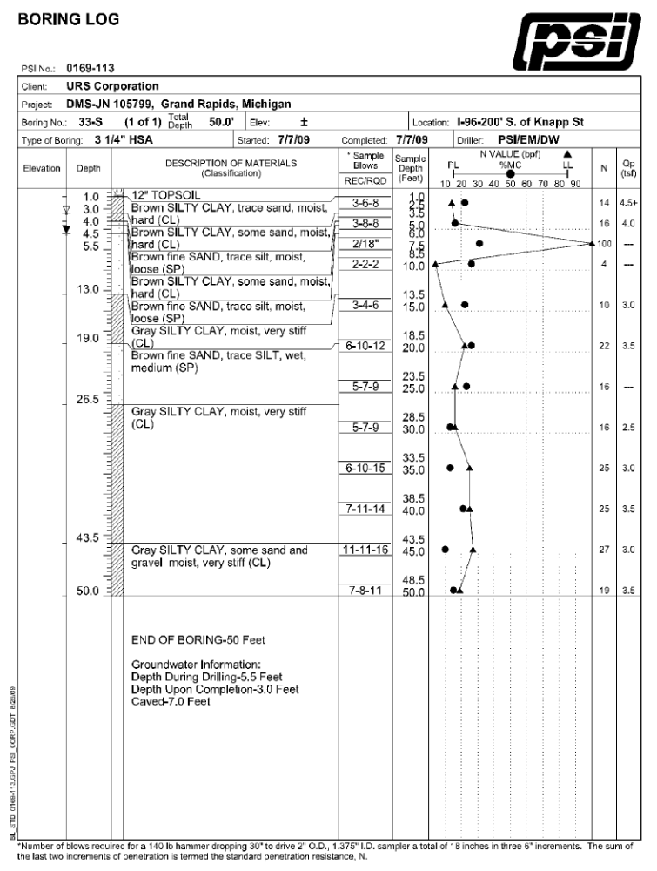
Figure 10 - Boring Log
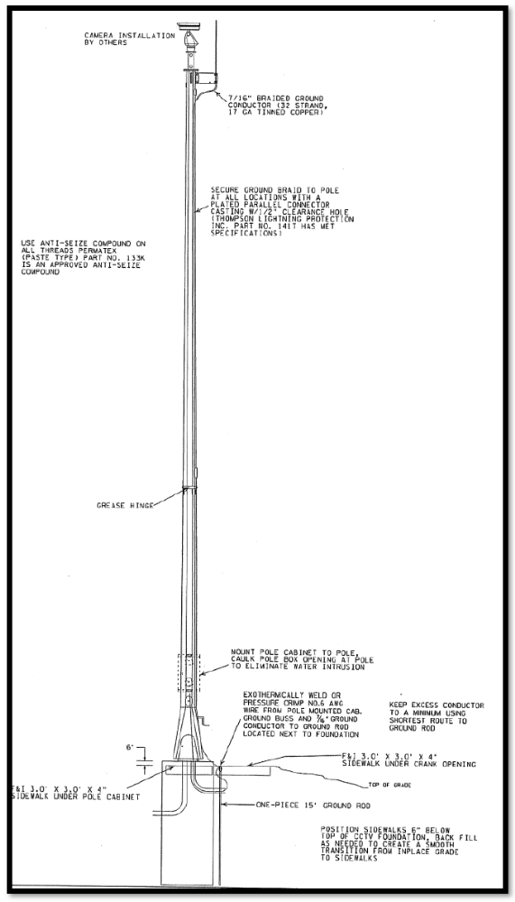
Figure 11 - Pole Design
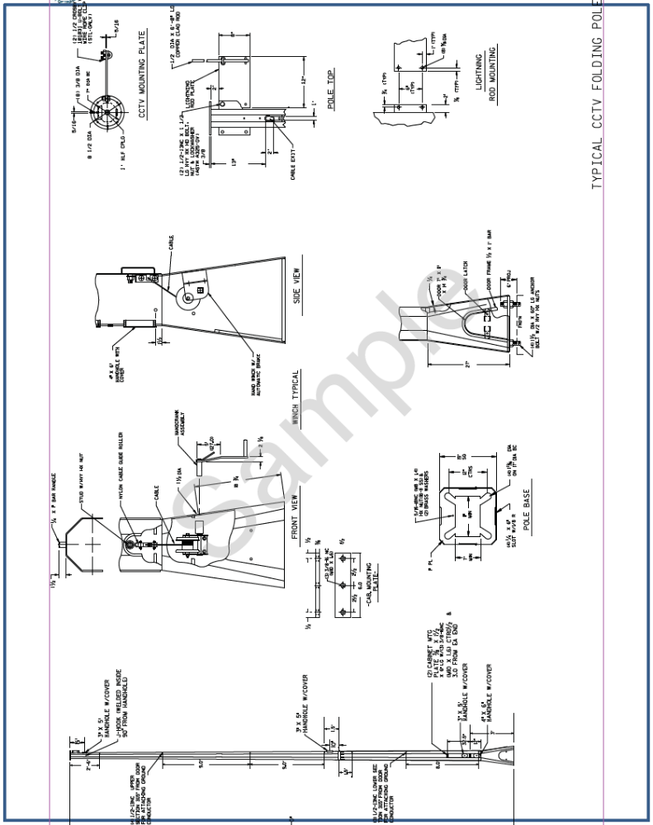
Figure 12 - Pole Mounting Design

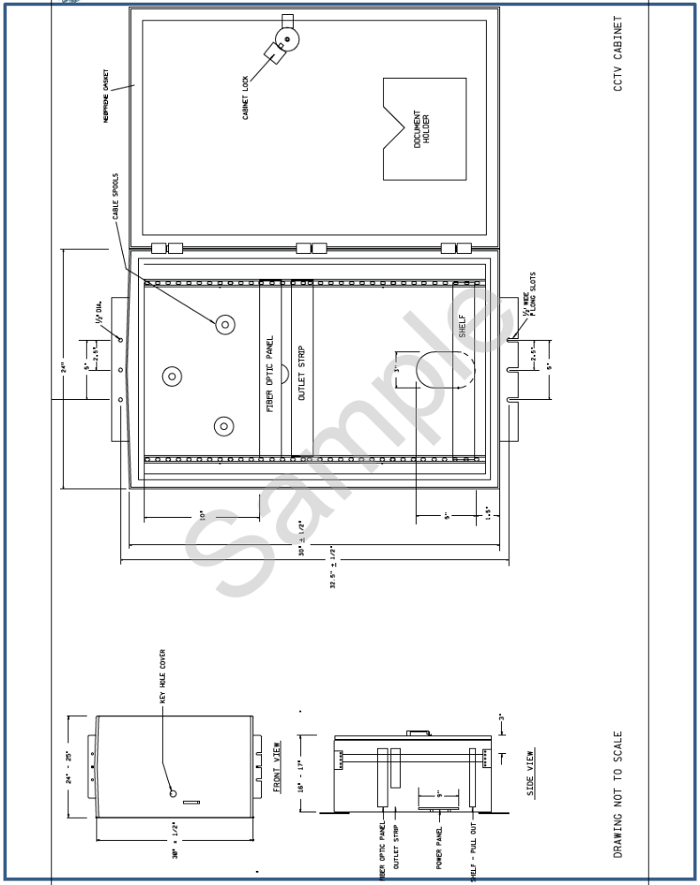
Figure 13 - Pole-mounted Cabinet Detail
- How would the design change if a BBS that weighed 40 lbs. was included in the cabinet?
Any conclusion with a valid rationale can be supported.
- How would the design change if a solar power source was used for power that included 400 lbs. for solar power electronics and battery capacity? How would 27 square feet of solar panels be mounted?
The biggest concerns would be the wind loading due to the solar panels and the required mounting height for solar orientation and resistance to vandalism. A separate structure to mount the solar panels and a separate cabinet for power electronics including batteries should be considered as an alternative.
Task 5: Project Evaluation
The challenge with deploying an ITS project is knowing that what was deployed made a difference or solved the problem that prompted it in the first place. For evaluation of the civil components, the evaluation is primarily focused on the corresponding portion of the System Engineering process, typically portions of a requirements document.
The effectiveness of the project may not be available at the conclusion of the civil portion. However, an ongoing correspondence with the goals of the ITS project allows the civil components to better integrate with future components in support of transportation goals. In some cases, flexibility in adjusting civil portions of a project may not be possible given constraints of legal, contractual, and financial arrangements already in place.
Without a complete requirements document, determining the specifics of the test cannot be completed. Please consider the following topics related to the test and evaluation:
- Is there particular information that is most valuable for the test to be successful?
The test needs to focus on requirements related to the details of the camera system. The ability of the camera to supply quality images to end users is the highest level need that can be directly tested and should be a major component of the test.
- How would completion of the camera component relate to expected user needs of:
  - Reduced complaints from drivers and transit users!
This is addressed indirectly by supporting better performance of the roadway.
  - Better wayfinding
This is not addressed in this exercise.
  - Reduced delays/congestion
This is addressed indirectly by providing better information to traffic managers.
  - Reduced emissions and fuel consumption
This is addressed indirectly by supporting better performance of the roadway.
  - Safer driving environment
This is addressed indirectly by supporting better performance of the roadway.
To put this task in perspective, it is important to have the class consider that the results of this project support the transportation goals, but do not directly affect measures of effectiveness (MOEs).
- How would you involve the interested agencies, institutions, and organizations listed in Table 9 in the appendix of this exercise in the project development or project evaluation?
In this scenario, there needs to be coordination between the City DOT and the State DOT for the camera implementation. Year-one projects also involve the University Transit Department and the City Transit Authority. All should be involved starting as early in the project as possible and throughout the project. Stakeholders should be invited to participate in review of the component design, even though their involvement in the project components may be several years away. Stakeholders should also be invited to review results of the implementation upon completion. Stakeholder input should be considered as valuable guidance, but the control of the project including decisions on proceeding are retained by the City DOT.

Final wrap-up
Upon completion of all tasks for this exercise, it would be worthwhile to go back to Tasks 1, 2, and 3 to show why there is a need to complete these tasks with analysis results prepared for design revisions. An emphasis on preparing for revisions in order to limit the cost of design rework is a valuable lesson.

APPENDIX - BACKGROUND INFORMATION
A football game represents the biggest event that your City has to accommodate. There are typically six to seven home games a year, each drawing close to 80,000 people into the City on game days. The university campus is located in the middle of your City. However, its football stadium is located off-campus, about two miles from the heart of campus.
In the past 15 years, traffic conditions on home game weekends have degraded each year. As the team has improved under new leadership, attendance has grown which has steadily increased car traffic and the tail-gating activities prior to and after game time. In turn, this has increased the congestion and spread it over a longer period of time.
To capitalize on this new found vigor for the football program, the University made a commitment to expand the stadium to accommodate an additional 15,000 seats. Thus, the record draw of alumni and fans to the games is only expected to increase as the stadium is expanded for more seats.
Once it was decided to expand the stadium, the University commissioned a study to assess the current and future demand being fueled by the record attendance. The study concluded that traffic conditions will not improve unless new roadway access and traffic management features are put in place. The roadway expansion is severely limited due to the unavailability of land for new roads around the stadium; therefore, using traffic technology is imperative.
Since the stadium sits off-campus and is surrounded by City-maintained streets and traffic signals, the University approached the City DOT engineer (and you) with their stadium expansion plans and completed traffic impact study. The study recommended a plan be developed to handle traffic before, during, and after the game on the campus grounds, the stadium grounds, the freeways, arterials, and local streets that surround the stadium and used for ingress and egress. The study made it clear that an overhaul of the existing City’s Traffic Management Center (TMC) would be needed in order to implement and use any ITS devices.
As you are painfully aware, traffic leading to and away from the stadium is under the control of the City Department of Transportation. Around the stadium, the City police department usually handles special traffic control providing travelers with direction as they enter and exit the area. It was recommended that traffic be directed by dynamic message signs at key locations to reduce police activities and to provide game day information, e.g., recommended exits, parking direction, etc., to those approaching the stadium via freeway. It was proposed that 6 portable dynamic message signs (DMS) be placed at key locations along arterials approaching the stadium and 2 overhead DMS’s be installed on the freeway in advance of the exits providing main access to the City and stadium. In addition, the study recommended that the City TMC provide traveler information via radio, website, and a mobile app to inform travelers of traffic conditions and provide routing based on current traffic conditions. Any new devices placed on the freeway will require coordination with the State DOT.
The study also recommended the implementation of vehicle detection/surveillance devices at 10 intersections, on two main arterials (8 locations total), and at four locations on the freeway that would feed traffic data to the upgraded City TMC, providing a clear picture for operators of the status of the roadways.
In addition, to better coordinate incident response, the City police will have an officer located in the City’s TMC on game days to better coordinate incident response. Video surveillance will be monitored from the TMC center allowing the officer to assess incidents within view of the nearest camera and directly dispatch response.
One of the findings in the study was the lack of information provided to motorists about parking. Parking is available on the University campus, as well as, in City and public lots. Parking area locations are ill-defined and occupancy levels unknown causing a lot of wasted travel and congestion. It was recommended that parking information be disseminated using technology so the public will know the locations of designated parking areas and the number of spaces available at each. Two major parking areas were designated as test beds for parking occupancy detection.
Transit service provided by the City Transit Authority will receive traffic conditions at the existing Transit Management Center. It was recommended that two special transit routes be provided on game days and that flexibility be built into the system to best serve the riders. This would entail some type of technology being implemented on 4 buses. Furthermore, the university operates 4 shuttle buses from on-campus parking areas to the stadium. It was recommended that transit options be coordinated between the City Transit Management Center and the existing University Shuttle Dispatch Center.
The university will make a sizeable investment in technology to accomplish this deployment. It will be accomplished over a period of 3 years. The City, recognizing the importance of improving traffic conditions on game days, has agreed to devote funds for these improvements out of their annual transportation budget over the same 3-year period. The costs associated with each ITS component, the subsequent TMC upgrades, the implementation and integration of the ITS technology, and the operation and maintenance costs of the system, all need to be considered in order to determine how to phase the project, i.e., based on your budget constraints each year, how will you stage your ITS technology deployments. Therefore, an ITS architecture is needed to properly plan and coordinate each phase of the deployment.
Taken from the ITS Architecture exercise, Table 5 provides a summary of the proposed ITS elements recommended for the project. It should be noted that the existing TMC will need to be upgraded to accommodate the new ITS devices shown in this table.
Table 5 - Summary of Project ITS Elements
ITS DEVICE TYPE | NUMBER OF DEVICES | STAKEHOLDER
Portable Dynamic Message Sign (DMS) | 6 signs | City Police Department  University Police Department
Overhead DMS | 2 signs | State Department of Transportation
Vehicle Detection/Surveillance Cameras | 10 Intersections (40 cameras)  2 arterials (8 cameras)  1 Freeway (4 cameras) | City Department of Transportation  State Department of Transportation
Parking Detection Systems | 2 Parking Locations (one City-owned, one University-owned) | City Parking Department  University Parking Department
Transit Technology Upgrade | 4 City buses  4 University shuttles | City Transit Authority  University Transit Department
Mobile App | 1 app for motorists | University Department of Transportation

In the following tasks, you will consider some of the civil design elements of beginning the implementation of the system.
In the ITS Architecture PCB case study, an assumption was made to follow a funding plan covering a three year implementation phase broken down as:
- Year 1 - $450,000
- Year 2 - $350,000
- Year 3 - $250,000

These funds represent the combination of funds allocated in the City’s transportation plan and contributions from the University. This funding can be used only for capital improvements including ITS but is not to be used for operations or maintenance resources at the City. You must assume that no more City staff can be added to operate the signal system that is currently in place.
A key factor in this type of planning, especially when the project you are working on requires integration of ITS components, is accommodating the functionality dependencies of the systems/components being implemented.
As provided in the ITS Architecture course, Table 6Error: Reference source not found lists common ITS components along with their respective capital costs and operating and maintenance costs. While the project is determined using the capital costs, the O&M costs will have impact on the City’s operating budget going forward. Note that the purpose of Table 6 is to provide a starting point and is not all-inclusive. There may be other ITS components you need that are not listed here; use the ITS cost database at http://www.itscosts.its.dot.gov/ to find costs for other components you may need.
Table 6 - Common ITS Component Costs
ITS COMPONENT | CAPITAL COST ($K) | O&M COST ($K/YEAR) | NOTES
Dynamic Message Sign (portable) | $21 | $1.6 | Per unit
Video Camera Sensor on Corridor | $24 | $0.3 | Two sensors, one in each direction of travel
Video Camera Sensor at Intersection | $22 | $1.0 | Four-way intersection, one camera each approach
CCTV Video Camera | $16 | $2.0 | Color video with PTZ
Signal Controller Upgrade | $12 | $0.4 | Upgrade signal controller at intersection
New Traffic Signal | $92 | $2.0 | Installation of a new traffic signal with video detection
TMC Upgrade | $300 | $50.0 | Upgrading the existing TMC to accommodate new ITS
GPS for Transit Vehicle Location | $2 | $0.3 | Automatic Vehicle Locator per transit vehicle
Parking Monitoring System | $35 | $2.0 | Includes detection and controllers for parking areas
Integration of ITS Devices | $100 | $2.0 | Costs pertaining to field work associated with connecting new devices to upgraded TMC
Note: For the purposes of this exercise, installation costs are assumed as part of the capital costs.
As starting conditions of this exercise, you have made choices on the implementation options for Year 1. The City Council wants to implement portions of the project immediately to impact the experience of fans visiting the city and to gain support for completion of the project components. However, the City has decided that upgrade of the TMC will be coordinated in a building remodel and will require 18 months to accomplish, delaying the TMC upgrade. Furthermore, the installation of freeway devices requires coordination with the State DOT, including development of a data and control sharing agreement, which is expected to cause access to freeway surveillance and deployment of overhead DMS to slip into year three. Transit upgrades to coordinate between the City TMC and the University Shuttle Dispatch Center also will require data sharing agreements and will be implemented in year two.
To achieve demonstrable progress in Year 1 installation, the city has selected technology upgrades that can be utilized with existing systems. The city will place 6 portable DMS at major intersections near the stadium and control display messages under using a staff member dispatched to the sign location as needed. The city will fund deployment of transit equipment improvements on both University and City Transit busses to provide flexible routing dispatched on game days, with coordination of the systems done between staff members from the City TMC. The city will deploy video vehicle detection at the 10 identified intersections, which are compatible with the existing traffic signal system, but will not upgrade the controllers or the signal coordination system. Because one of the intersections is adjacent to the freeway and frequently operates at LOS F prior to football games, the City wants video surveillance of both the intersection and the nearby freeway exit ramps. The city operates a multi-pair copper communication plant for city center coordinated signal operations, which stops 2000’ from the intersection of interest. Our exercise is to design surveillance of the ramp for year one deployment. The bolded items in Table 7 reflect the items chosen for year 1 deployment while the italicized items will be deferred to future years.
Table 7 - Selected ITS Project Elements
ITS DEVICE TYPE | NUMBER OF DEVICES | STAKEHOLDER
Portable Dynamic Message Sign (DMS) | 6 signs | City Police Department  University Police Department
Overhead DMS | 2 signs | State Department. of Transportation
Vehicle Detection/Surveillance Cameras | 10 Intersections (40 cameras)  2 arterials (PTZ cameras)  1 Freeway (PTZ camera) | City Department of Transportation  State Department of Transportation
Parking Detection Systems | 2 Parking Locations (one City-owned, one University-owned) | City Parking Department  University Parking Department
Transit Technology Upgrade | 4 City buses  4 University shuttles | City Transit Authority  University Transit Department
Mobile App | 1 app for motorists | University Department of Transportation

The O&M costs include the costs to operate the systems employed and the costs to maintain these systems. For example, for a signal system, the cost of electricity is figured into operating costs while the upkeep of the signals (replacing hardware, servicing malfunctioning signals, etc.) comprise a bulk of the maintenance costs. It is very important that O&M costs are considered as part of any project; they will be with you for the life of the components! Without O&M funding, systems will not be able to operate efficiently or for very long. Table 8 shows estimated costs for the first year of the project. The implementation costs are typically covered by the installation project, while the operations and maintenance costs must be included in operational budgets, which typically are developed by local agencies. It should be noted that the O & M costs for the first year project elements will usually not reach the budgeted annual costs due to the project elements only operating for a portion of the year. There are also frequently one-time costs associated with operations, such as hiring, training, and contract establishment that we take a portion of the unrealized O & M costs.
Table 8 – Estimated First Year Costs
ITS DEVICE TYPE | NUMBER OF DEVICES | PER DEVICE INSTALLATION COST ($K) | TOTAL INSTALLATION COST ($K) | PER DEVICE ANNUAL O & M ($K) | YEAR ONE  O & M ($K)
Portable DMS | 6 | $21 | $126 | $1.6 | $9.6
CCTV - Freeway Interchange | 1 | $16 | $16 | $2 | $2.0
CCTV Detection - Intersection | 10 | $22 | $220 | $1 | $10.0
Transit GPS | 8 | $2 | $16 | $0.3 | $2.4
TMC Upgrade (Initial stage) | 1 | $70 | $70 | $0 | $0.0
Year One Costs |  |  | $448 |  | $24

The upgrade and implementation of ITS is rarely able to be implemented by a single organization without consultation with other agencies and stakeholders. The selection of year-one projects has used the ability to act rapidly as one criterion for inclusion. Table 9, which is updated from the ITS Architecture course, summarizes the organizational responsibilities for candidate projects with year-one projects highlighted.
Table 9 – Typical Organizational Responsibility
SYSTEM IN PROJECT | STATUS | ORGANIZATION
City Traffic Management Center | Existing & Planned | City DOT
Dynamic Message Signs | Planned | City DOT/State DOT
Personal devices (radios, computers, tablets, cell phones, etc.) | Existing | Travelers
Vehicle detection devices | Planned | City DOT
Parking monitoring equipment | Planned | City Parking Lot Operators / University Parking Department
City Transit Management Center | Existing | City Transit Authority
City transit vehicle equipment (tracking, etc.) | Existing & Planned | City Transit Authority
University Shuttle Dispatch Center | Existing | University Transit Department
Video surveillance cameras | Planned | City DOT/State DOT
City Police Dispatch System | Existing | City Police Department

